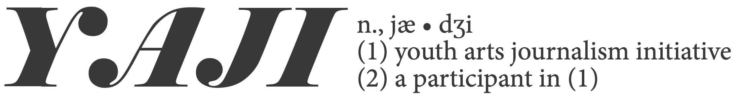

Lucy Gellman & Melanie Espinal
The Arts Paper | Youth Arts Journalism
NEFA Creative Communities Exchange 2019

YOUTH ARTS JOURNALISM INITIATIVE | ANNOTATED TIMELINE SEPTEMBER-DECEMBER 2018
Internally: Evaluate the curricular/analytical framework in place and figure out what changes will need to be made with plenty of time to make them. Identify key programming partners (for us this included the New Haven Free Public Library). Continue to apply for sources of funding. These may include: state, national, foundation and corporate grants, as well as private donors.

By mid-December, open applications for a part-time YAJI Program Assistant who can assist with the logistics of the program, from curricular development and program planning to in- kind food donations. Start planning for weeklong writing intensive.

Externally: Begin outreach to teachers, guidance counselors, administrators, parents and students and YAJI alumni in the city’s public high schools. Schedule a time/times to meet with the city’s Board of Education and related affinity groups to describe the program, show materials and student writing from the previous year.

JANUARY 2019

Internally: By the end of the month, close applications for a YAJI program assistant and conduct applicant interviews. This person should come on no later than early/mid February. For the Arts Paper, it was important to us that they both had a journalism background and reflected our kaleidoscopic community.

Finish drafting/updating application language for students; prepare it for both web and print distribution. In addition, begin reaching out to any corporate headquarters for major in-kind food donations (Stop & Shop, etc.).

Externally: Continue outreach efforts!

FEBRUARY 2019

Internally: At the beginning of the month post YAJI application to website and field any questions from students that come in. With YAJI Program Assistant, begin finalizing curriculum for the weeklong intensive.

Also begin reaching out to local restaurants and cafes to ask about in-kind food donations for the weeklong intensive. Confirm community partnerships and visiting artists.

Externally: Keep reaching out to students even as applications roll in. We sent a big email blast when we launched the application, followed by weekly email blasts with information on YAJI and a quick link to the application form. In mid-February, we also offered a “YAJI Mock Session” at the Yale University Art Gallery, so students could get a sense of the program.

MARCH 2019

Internally: On March 1, close and begin to read applications. We gave ourselves two weeks, finalized decisions in a group, and notified students on March 15. If the curriculum is not already done, continue to finalize it during this time. Also confirm/order/buy the following by the end of the month: youth bus passes, in-kind food donations that are not yet finalized, steno pads and pens.

Externally: Notify all students on March 15. Because we had 10 slots, we notified both accepted and waitlisted students by email. Accepted students had until March 29 to claim their spot, then we began pulling students from the waitlist. We also made sure that we had students’ contact information, to get in touch if we needed to.

EARLY APRIL 2019

Internally: Draft and print contracts and photo releases for each student, finalize any last details for the intensive. Because students are technically learning about the gig economy and work for hire, we used the same language we would when contracting a freelancer.

Externally: Confirm program dates and participation with accepted students. We launched the five-day intensive during NHPS spring break, which fell on April 15-19. During this week, our home base was the New Haven Free Public Library from 10 a.m. to 3 p.m. each day.

MID APRIL-JUNE/TUESDAYS, APRIL 23-JUNE 4 2019

Internally: Prepare a weekly “pitch document” with the YAJI Program Assistant, with 15-20 potential assignments for youth arts journalists to work on during the remaining weeks of the program (in our program, we are also very open to assignments that students propose themselves). Edit student work as it comes in.

Externally: Hold weekly “pitch meetings” with all students one afternoon per week, with optional office hours one additional afternoon per week. Angle with students after assignments, set deadlines, edit collaboratively and publish the works on newhavenarts.org.

