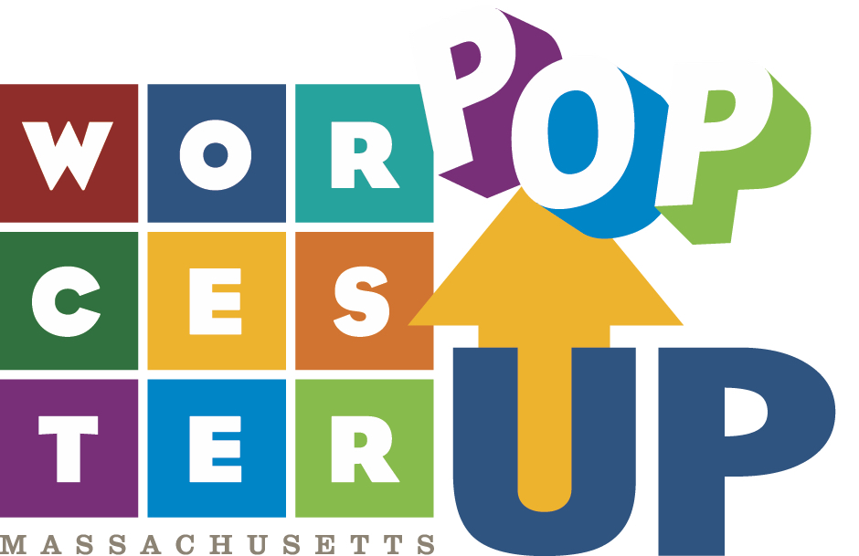

To Do List

- Identify a need in your community
- Comparable cities, what are they doing?
- What are your demographics?
- What is the density of artist, entrepreneurs, community organizers in your target area?
- Community feedback is vital during the initial brainstorming phase.
- Local census, town halls, surveys, facebook polls are all important avenues of information gathering.
- Use the tools of the day to gather the most current information possible.
- Your connection to the community begins here with inclusion and outreach.
- Identify community/regional partners needed
- Begin with organizations already in the community and with vested interest in development.
- Seek expertise in proposed program goals.
- Seek organizations experienced at fundraising.
- Seek partners with comparable operational experience.
- Seek partners with existing community ties and established trust whenever possible
- Identify facility location
- Central to target population density.
- Accessible: reliable public transportation nearby? Access to other support services nearby? Are there other cultural organizations within reach that can be tapped into on a case by case basis?
- Preferably your community partner committee can provide access to applicable facility space or ability to repurpose existing space.
- Develop funding goals to support plans
- Determine core goals of new facility.
- Identify primary components for budget planning and space goals (A.V equipment, P.A system, gallery lighting, professional sound etc).
- Identify secondary components for budget planning ( signage, furniture, promotional items).
- Develop slush/discretionary funding pool. There will always be items and situations you did not account for. Empower your director to address those efficiently by establish this budget.
- Operational budget to include items like website cost, rent, utilities, director salary, interns, mentees if applicable.
- Create sub team specializing in various aspects of plans;
- You and your partners will work together to bring on buildout team. That team will likely include engineers, architects, lighting professionals, sound designers, etc
- Rely on core partners to tap into their contacts and draw from their experience in hiring and negotiations.
- Consider build out stage/progress in unison with any remaining fundraising goals in mind. Tie milestones into promotion for remaining funding. This is an opportunity to show funders where their money went. Very important, especially if anticipating further fundings asks.
- Identify program managing director and bring on during construction phase
- Director with pre existing ties to communities, especially underserved immigrant, etc
- Seek someone with experience organizing and management
- An artist is ideal as the position needs to be someone relatable
- This position will require flexibility, problem solving skills, ability to work under stress, and good communication skills
- Coordinate furniture/fixture acquisition during final stages of buildout
- Inform final build phase as to final arraignment of components (projector, speakers, lighting, etc)
- Begin development of operating policies and application process.
- Develop community oriented program policies and operational plans
- PopUp Director develops operational strategy and policies.
- Develop social media presence.
- Create a communication plan and coordinate with coalition.
- Develop an application process that is easy to understand and as automated as possible. It should also require key information about event, (target audience, event goal, funding if any, etc).
- Create/include forms and contracts used.
- Develop basic facility policies keeping in mind that these will evolve.
- Determine initial hours of operation that include office hours and event hours of operation.
- Develop sub-programs/projects developed or relaunched under popup banner (artist in residence program, worcester windows, etc) that support main goals of your space.
- Launch phase
- Implement strategies and tactics.
- Observe and continue to require feedback as part of your process.
- Exit surveys required by all who use space.
- Continue to ask your data to answer these questions: What did you do well? What can use improvement? What areas can be made more efficient?
- Goal is to gather proof of concept evidence or adjust policies and procedures as needed to better serve end goals and overall mission.
- This is an ongoing process of adjustments.
- Must remain relevant to a growing community and that requires a constant feedback loop of metrics, analysis, and adjustments.

