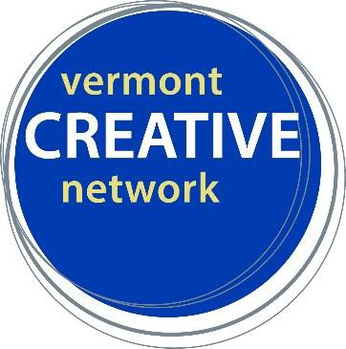Creative Economy Research and Planning
Tips from our work in Vermont’s Northeast Kingdom

TIMELINE:
- Pre-phase 1: Coordinate funding and confirm consulting team.
- Phase 1: Create advisory committee. Review past creative economy data (from VT and NEK). Create stakeholder engagement plan.
- Phase 2: Research and analyze creative economy and the broader NEK landscape. Conduct interviews and host focus groups.
- Phase 3: Formulate action plan, with input from advisory committee.
- Phase 4: Release final reports. Implement communication plan.

TIPS FOR SUCCESS:
- Work with partners outside of the arts sector. Align with other community and economic development work happening in your area.
- Get clear on your definition of the creative economy and what it will include. In the NEK, there is incredibly strong expertise and leadership in the local food sector, so getting their guidance and buy-in has been helpful.
- Your consulting/research team should include expertise in economic analysis, as well as community and economic development. Consultants with national experience were invaluable in bringing models and perspective from elsewhere; likewise some team members with an understanding of Vermont were helpful.
- A strong, well-represented advisory committee is key. Include community leaders outside of the creative sector.
- Ask local advisory group members to assist in identifying invitees for regional focus groups.
- Be clear in your outreach and communication about a project like this. Who’s doing it? What is it for?

Presented by:
- Amy Cunningham, deputy director, Vermont Arts Council, acunningham@vermontartscouncil.org
- Jody Fried, executive director, Catamount Arts, jfried@catamountarts.org

Download NEK Creative Economy Executive Summary here: https://bit.ly/2QLKube Download NEK Creative Economy Full Report here: https://bit.ly/2Z9Ek7D
CCX 2019: “Building on a Legacy of Creativity: Understanding and Expanding the Creative Economy of the Northeast Kingdom” www.vermontcreativenetwork.org

