Spark is a community-driven hub, in Greensboro, connecting people, businesses, and resources. Our goal is to strengthen the economy of the Northeast Kingdom, of Vermont, by providing entrepreneurs, artists, and students with access to professional services, equipment, technology, and education opportunities.
This is a project of WonderArts Vermont - www.SparkVT.org
Contact Ceilidh Galloway-Kane at ceilidh@wonderartsvt.org

How we holistically support entrepreneurs & small businesses…

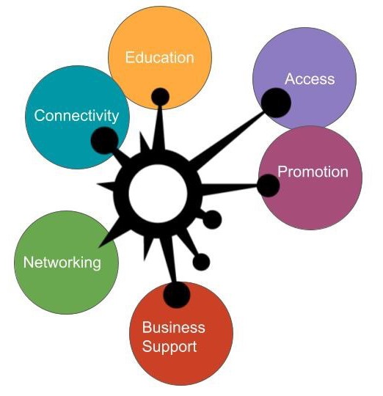Access | Providing Spark members and the general public with 35+ hours a week of access to 3D printers, internet, iMac computers, large format printers, laser cutter, tools, and space
Promotion | Providing opportunities to develop marketing and promotion skills through software, product photography, vinyl cutter, and peer review Business Support | Providing one-on-one business services in branding, fundraising, visioning, technical assistance, HR, accounting, software, technology, and equipment training
Networking | Bringing people together to meet, exchange ideas, partner, and connect
Connectivity | A space with high-speed fiber internet
Education | Weekly classes focused on business development, innovation, creativity, and technology

How we have served our community over the past year

45 members & 355 visits to the space | 242 equipment & software users | 17 businesses directly served through one-on-one coaching | 87 people connected | 200Mbps up & down | 118 class participants | 35 classes | 52 students | 97% of classes taught by members | 60% of members are women

Why Spark? In 2017, WonderArts identified a need for supporting young professionals in our rural community. To retain, attract, and grow small businesses and innovation we needed to expand programming to this demographic. For 6 months, we held community meetings, met with individuals, and worked with community partners. We met with artists, farmers, shop owners, architects, engineers, inventors, students, cheesemakers, and more. What we heard loud and clear was that our community needed access, not to a kiln or woodshop, but to a powerful computer, high-quality printers, laser cutters, classes on website development, marketing support, and high-speed internet. With funding support from USDA Rural Business Development and the Vermont Community Foundation we created Spark. A space that seeks to meet all of the nuanced needs of entrepreneurs in our community.
Our check-list for starting something like this in your community!
- Identify what your community (individuals, organizations, businesses) need
- What resources and assets do you already have access to? Are you connected why or why not?
- Identify all of your potential stakeholders and find ways to hear from them about what they need to be better off
- Bring a group of 6 - 12 people together to serve as a steering committee for your project
- Decide who is going to be responsible for what and build ownership for these very important folks
- Brainstorm project goals and what will make your project successful (in the short-term and long-term)
- Decide how you will operate (501(c)3, LLC, through a fiscal agent, etc…)
- Create a budget. You will need seed funding. Where will that come from? Get it.
- Plan some pop-up/prototyping events and/or community meetings
- Evaluate these events. Who actually showed up? What were they excited about? What didn’t work?
- Find a space (preferably a cheap one) and go back to those stakeholders to ask for donations and help!
- Throughout the process be documenting and sharing this with your community through PR, social media, etc.
- Once you feel pretty confident about your space, systems, and vision…Open!

Resources that helped us develop our goals, vision, and space!
- Co-Working in Vermont, A Starter Guide & Check List - By Local 64 & VT Center for Emerging Technologies, www.vcet.co/coworking-in- vermont-a-starter-guide/
- Identifying Obstacles to the Success of Rural Business Incubators - Business Incubation Association, May 2001.
- Our local and regional Planning Commissions, maker spaces & co-working spaces, Small Business Development Center

