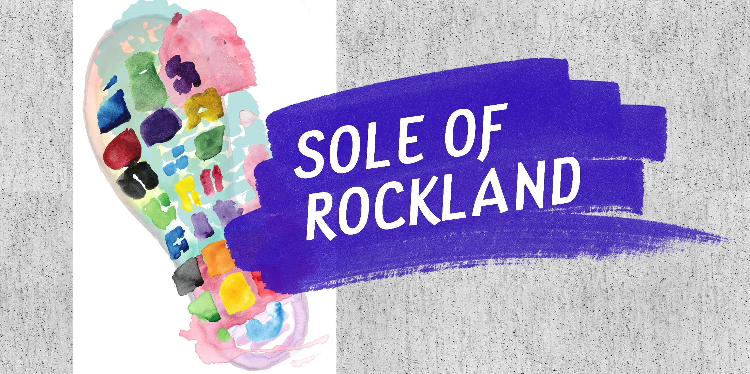

Sole of Rockland: Steps Towards Transforming the Identity of the Downtown

Project Description:
Working with the REiMAGINE ROCKLAND Arts & Culture Subcommittee and an Advisory Committee made up of local residents and representatives, a team from the Metropolitan Area Planning Council (MAPC) developed a creative placemaking demonstration project concept inspired by Rockland’s history as a center of shoe manufacturing. This project celebrated its flourishing community of artists who are transforming the town’s old factories into art studios and creative businesses. Engaging residents at the 2018 Rockland Farmers Market through an art-making activity and conversations about their favorite places in Rockland, the project generated temporary public art in the form of sidewalk paintings, sculptural seating for the downtown, as well as data to inform a long-term creative placemaking strategy and upcoming planning initiatives.

To Do Checklist:
- Assemble Your Project Team:
- Artistic Lead: Defining artistic product and process to meet project goals; coordinating fabrication and installation
- Project Manager: Managing project budget, timelines, coordinating meetings and outreach, integrating artistic process with planning priorities
- Local Project Coordinator: Making connections to local stakeholders, local activities and opportunities, and volunteers; managing project logistics and schedules
- Local Champion: Building buy in and support from key decision-makers and local community
- Marketing and Outreach Coordinator: Coordinating and copy editing content and messaging; managing social media and graphic design support
- Articulate the shared values of this team and goals of the initiative
- Lead Artist comes up with some options for artistic interventions/activities/public art to bring to the group to discuss.
- Pick one that leverages local resources and involves the community, especially youth!
- Look into any permitting issues that might arise on the selected site.
- Look into any insurance/liability that might be needed.
- Secure funding sources.

