Placemaking through Music:
Music Haven's Inclusive Placemaking Project
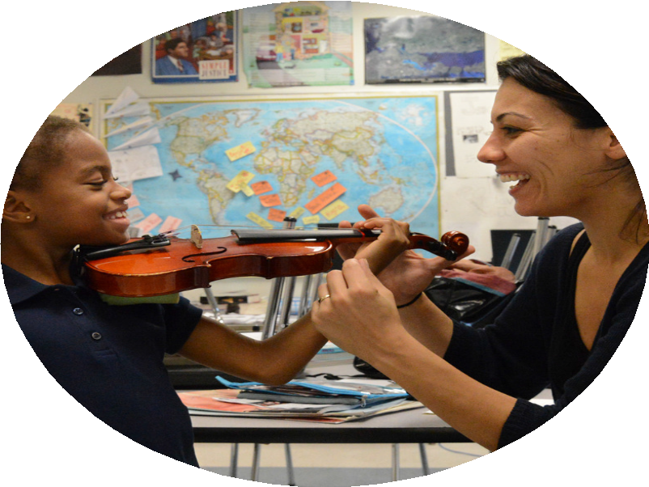Programming and relationships come first.
Have a proven model, longstanding positive relationships with all stakeholders, and demonstrated program results before you invest in a space. Build it and they will come? Not so much. Get them to come first, then you can build it. We leveraged the the relationships and programming we had created and nurtured over more than a decade to make the space a reality. It wouldn’t have worked the other way around.

Make a conservative budget and stick to it.
Be clear about what you can spend on occupancy costs. Set a budget based on the presumption that there will be many unanticipated costs. (In other words, if you think you can afford
$12 per sf, find a place for $10!) If you are renting, and a build-out is required, see about paying down the cost of that work over the life of the lease. Don't be so dazzled by a space that "looks perfect" that you start figuring out ways to "make the numbers work."

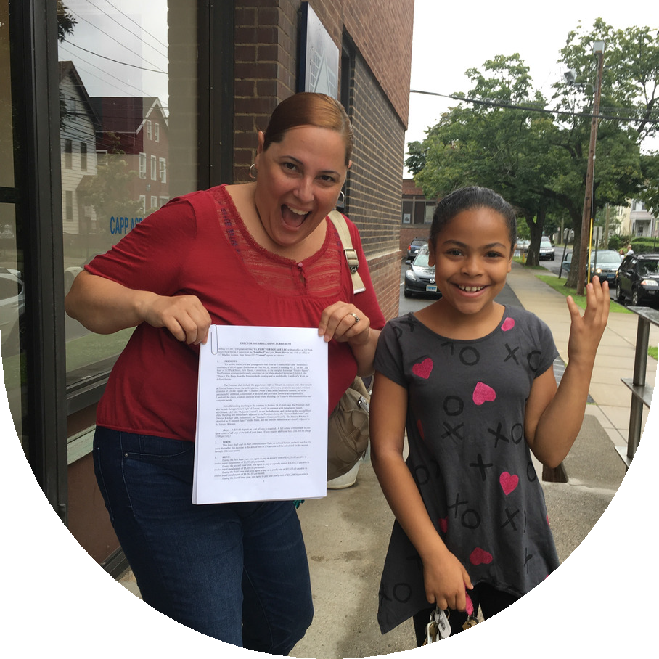Finding, securing, setting up, and maintaining a space is a JOB. Staff it!
You need a dedicated experienced staff person to oversee the whole process, from search to negotiating a lease, to supervising construction process. Make sure someone on your team has the skills to build and manage relationships with property owners, real estate agents, architects, contractors, and board members, and the time to manage this process. They need the ability to be
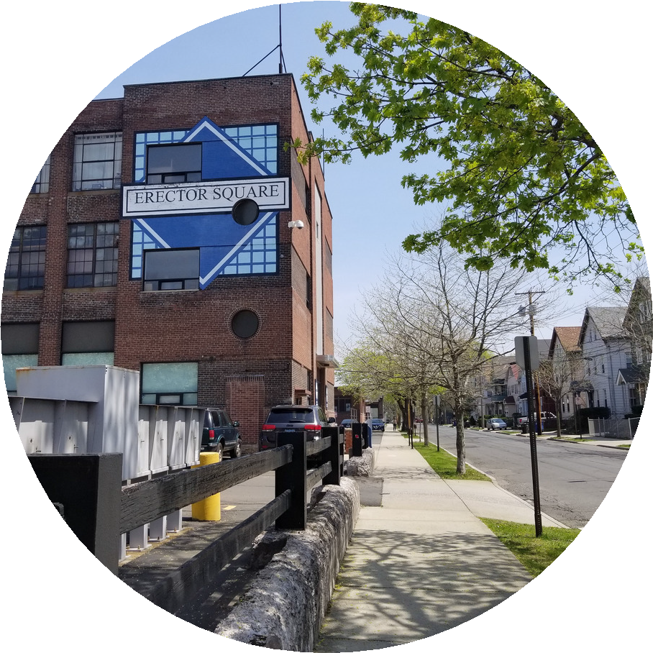assertive and flexible, and also generally charming, because you'll want them to negotiate in-kind work and materials.

Parking, Zoning, Accessibility, Traffic Flows!
It may be tempting to focus on finding the place with the big windows, natural light, perfect vibe, or right down the street from some great coffee shops, but sit down with an expert and talk about zoning, parking, accessibility for those with mobility issues, and traffic flows about any site that you're seriously considering. These issues can not only delay your process, they can cause long-term, time-consuming, and sometimes costly problems.

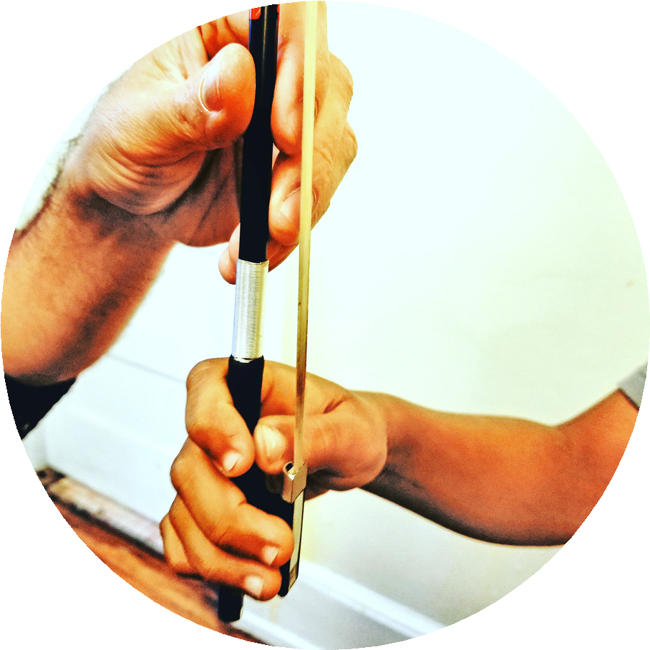RELATIONSHIPS, RELATIONSHIPS, RELATIONSHIPS.
With your neighborhood association. With your local elected officials. With the landlord. With the person who fixes stuff in the building. With the police precinct captain. With the fire marshall. With your local Arts Council. With the Chamber of Commerce. With City Planning Department. With the parking enforcement officer.
With the UPS guy. With organizational partners. Send them free tickets to events. Send them thank you cards and pictures drawn by the cute kids you serve. Make sure everyone knows what you do and why. Make sure they know how much you appreciate their help, even if they aren't very helpful.

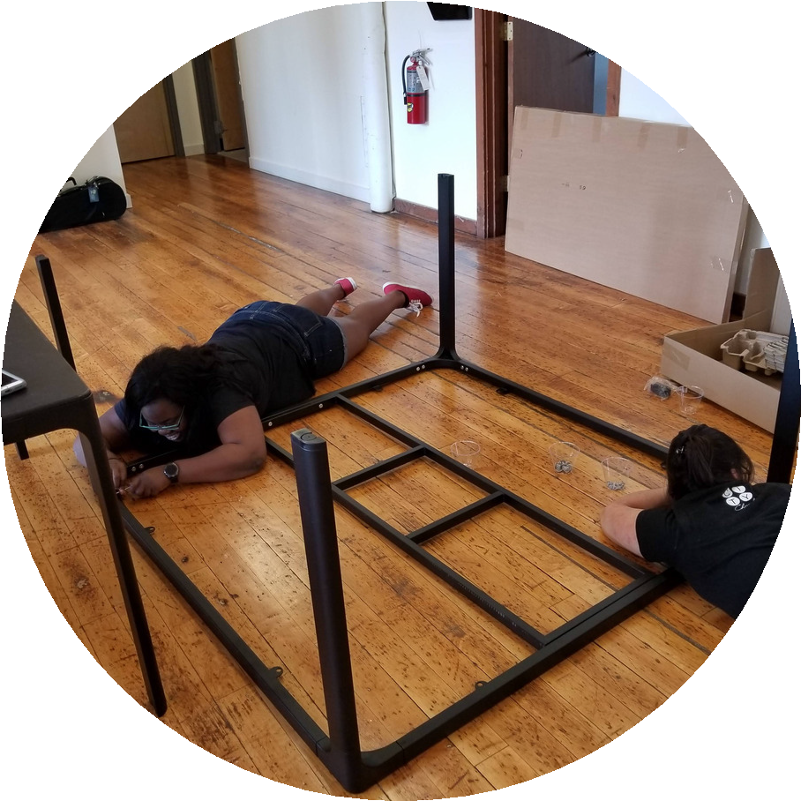Be cost conscious, but don't be cheap.
Yes--ask for donations of furniture, labor, equipment--but keep in mind that what you’re building is not only a place to do a thing, but an environment that people find welcoming and worthy of investment.
So apply to IKEA for an in-kind gift of new conference tables, and then get volunteers to assemble everything. Only take donations of
new or gently used furniture. Be picky. Don't create a space that looks desperate or temporary if you want people to invest in you. Don't DIY electrical work if you're not an electrician.

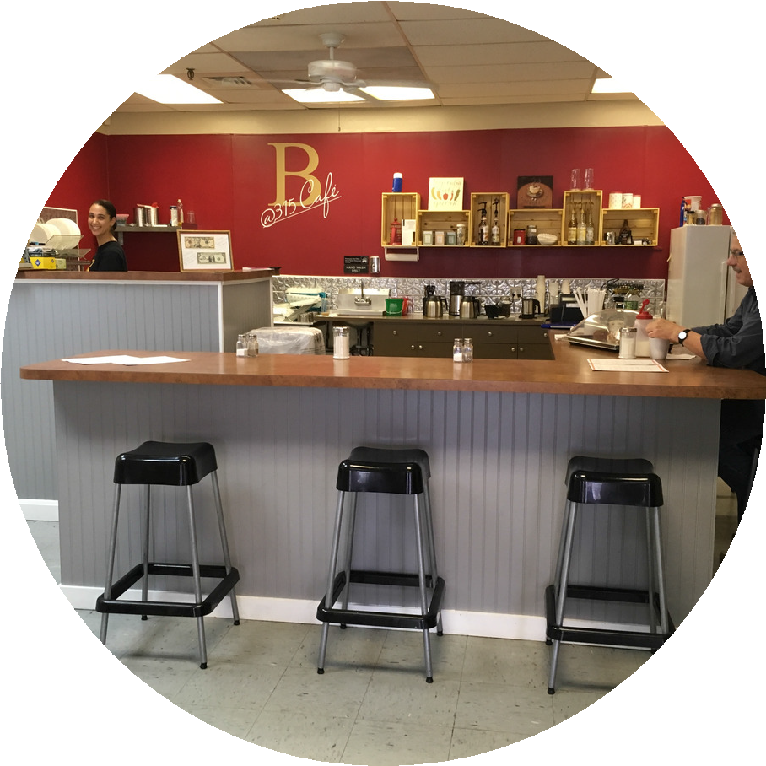Be a good neighbor.
This is especially important if you have lots of kids playing “twinkle” on violins for 3 hours every afternoon! INVITE neighbors to paid events for free, WARN them when you’re having an event that would impact any shared parking. BUY their goods and services when you can. PUBLICIZE their events when appropriate. Shout them out on social media when they show up or support you. Make sure you take the time to tell them about what you do, give them a VIP tour.

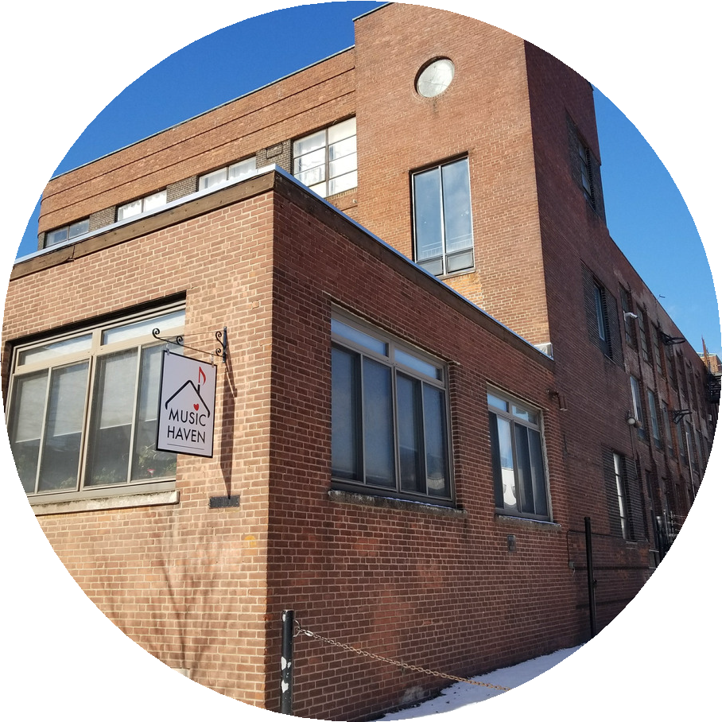Signage matters!
Street-level visibility is ideal, so figure out how to do that even if you aren't on the ground floor. Consider not only permanent signs on the building, but also temporary sandwich board signs for events. Check with both your landlord and the city/town ordinances relevant to signage. Walk outside and think about how to make the space
visible to both passing cars and pedestrians. Also consider how they'll find you once they enter the building. Invest in quality, professional signage--this is not something to DIY.

