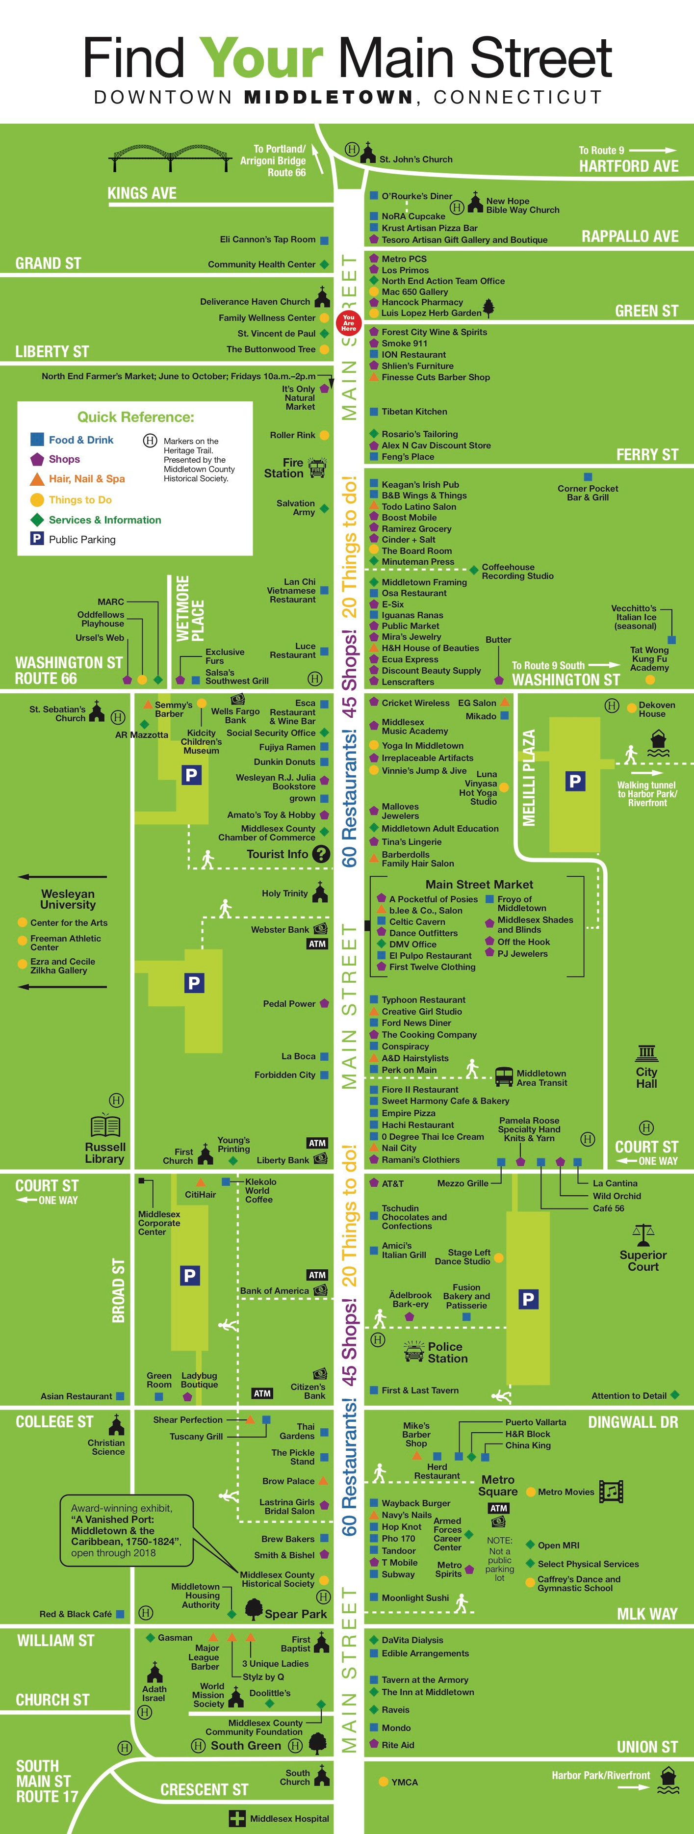

Find Your Main Street
Meet Your Main Street
A Wayfinding and Storytelling Project, 2018-19

Project Goals
- Encourage downtown visitors to explore beyond their usual destinations.
- Tell stories of civic engagement and creativity that visually demonstrate the diversity and passion of Middletown’s entrepreneurs & business community.
- Increase self-awareness for businesses of Middletown.

Sign Specifications
- Three-sided sign structure, wraps every other streetlight pole.
- Base of folded black aluminum.
- Top panel of 9.5” x 25” aluminum, screwed to base
- Signage printed on vinyl laminate, sticker adhered to top panel (specs).
- For easy updating, make spare set of top panels.
- In sign shop, use heat gun to strip sign from old panel for use in next cycle.
- Installed at 44’ to 48” at bottom of sign. Tension bracket to mount onto pole
- Match colors/branding with other downtown marketing

Map Panel Considerations
- Reprint every 6 months or as needed.
- Print all storefront names, including non-profits/services.
- Use larger icons for landmarks and amenities.
- Color/shape key to identify restaurants, retail, services etc.
- Option to call out short term events/exhibits within timeframe in blank areas.
- Install map with real east/west orientation for clarity of use

Story Panel Considerations
- Identify 25 candidates for profile, considering diversity of age, gender, race/ ethnicity, business type, role/status in business, alt/mainstream character.
- Install signs at a distance from store/location of profile subject.
- Photo essay includes subject’s other interests, personal journey, 3 photos
- Reprint annually as needed.

Banner Panel Considerations
- Redesign and replace seasonally. Panel is parallel to street, seen by cars.
- Option to invite artists/businesses/students to design changing panel.

Project Process
- Approval from Public Works, Planning, Mayor, Chamber & stakeholders.
- Funding from Downtown Business District (initial costs, $1,500 writing/ photography; $4,500 graphic design; $13,000 sign construct/install. Annual update costs $5,000).
- Recruit team: graphic designer, writer/photographer, signmaker, coordinator.
- Coordinate selection of subjects; agreement/release from subjects, scheduling of interview/photos, review editing and design drafts, secure final approval from subjects before printing.
- After completion, load profiles to downtown website & hold a celebration!
- 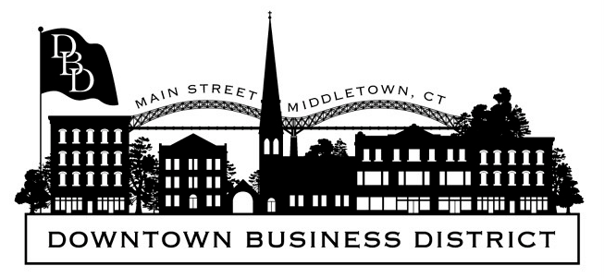Timeline: soft planning phase 1-2 years, active phase 6-8 months

Jen Alexander, Kidcity Children’s Museum director@kidcitymuseum.com;
Rani Arbo, Wesleyan University, rarbo@wesleyan.edu

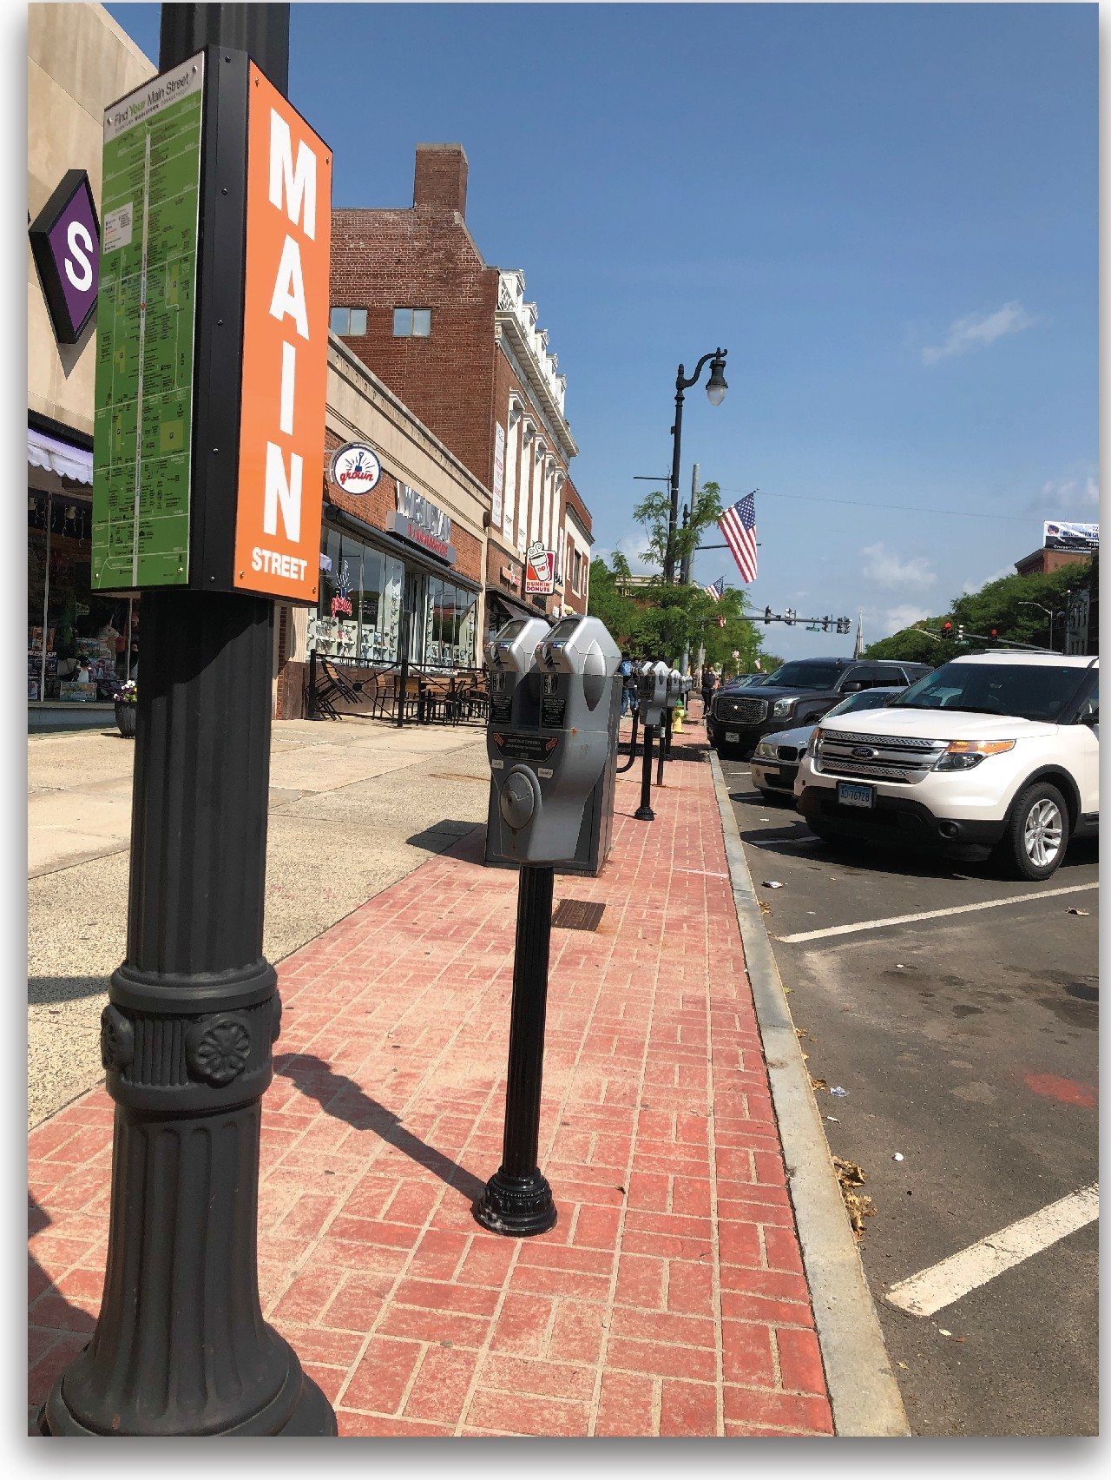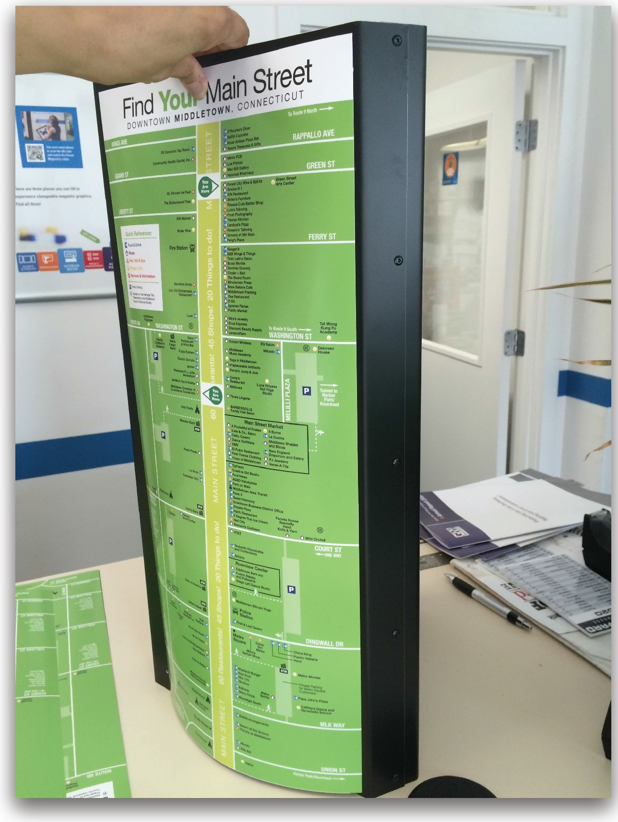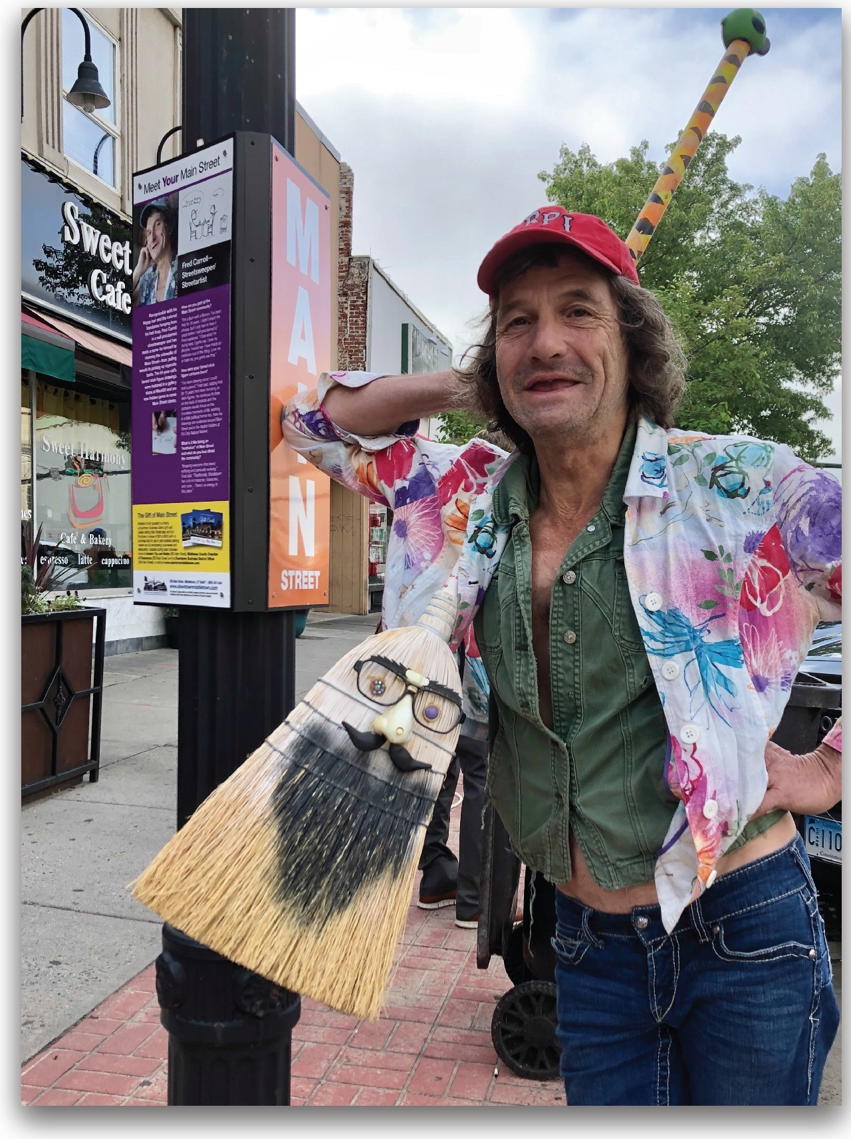
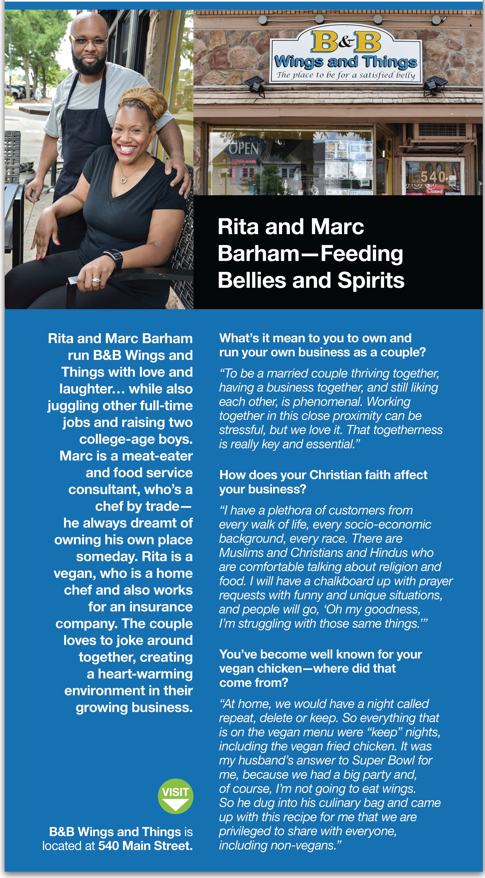
Meet Your Main Street

