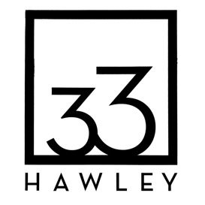Steps to survive a successful creative economy

v Identify the conundrum for stakeholders and believers in the potential of arts and culture to boost and support a local economy
- long term success inflates market prices and drives art makers out of the community … loss of two key arts spaces became our driver
- gather key stakeholders and arts leaders to brainstorm and identify conundrum and what’s at risk
- develop space needs survey for creative community to help determine path forward
- begin to develop concept, ideas, mission around creation of a new entity that could do for creative spaces what land trust do for land
- spaces for creative work that will drive an imagined community renaissance need to be secured for the long term, as in forever
v Develop the frames for differing stakeholders
- for civic leaders, protected space as an anchor for their economic development dreams
- for creatives, protected and affordable space as a tool for shared use
- does an arts trust, adapted from a land trust model lead clear mission and purpose?
- Keep community and press abreast of your initiatives
v Bring together a core group of potential users and community members willing to invest possibly an unreasonable amount of time in the endeavor
- further identify creative community space needs
- due diligence — conduct feasibility studies to determine scope of a first project and potential for capital campaign; focus on what you want to know at the end of such studies
- incorporate the entity (Arts Trust) that will be raising the funds

- develop a core corps of fundraisers/donors who can underwrite early stage development — EMILY, early money is like yeast — those who can give and those who can get; start with pre-existing social networks, one degree of separation
- appreciate the value of financial and social capital — you’ll need both
- start looking
v Secure a space as first project
- ask around, make cold calls, be bold
- take your time and get assessments from local architect before securing space
- secure the space with high level donors or low interest loan
- Activate the space before renovation so community buys in.
- open it to users even if you have renovation plans — especially if you have renovation plans
v Renovations — think big in tiny pieces (as in phases)
- start with a master plan, but maintain flexibility and CAN DO attitude
- Work with local architects and builders – more community buy in
- invest in efficiency, affordability

