HARBOR VOICES

Harbor Voices Public Art makes community collaborative free and public audiovisual art exhibitions. We believe that art, particularly participatory projects, has the ability to bring people together and impact the future. Through storytelling sessions and public art, Harbor Voices celebrates cultural diversity, augments family and community bonds, and creates resilience in our youth participants. Through our work, participants deepen their understanding of the immigrant experience, celebrate cultural identity, experience enhanced empathy and acceptance by discovering shared experience, and gain confidence that their voices can be a vehicle for social change.

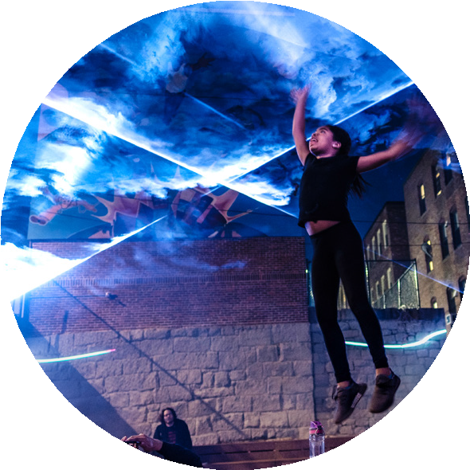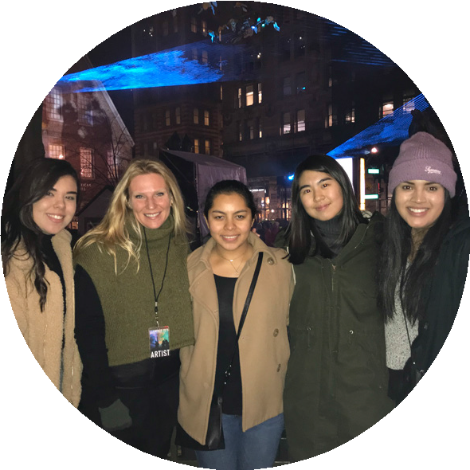Partner with local educational, municipal, and non- profit organizations.

HOW WE DO IT...
Host storytelling sessions to capture ancestral & recent stories of immigration.

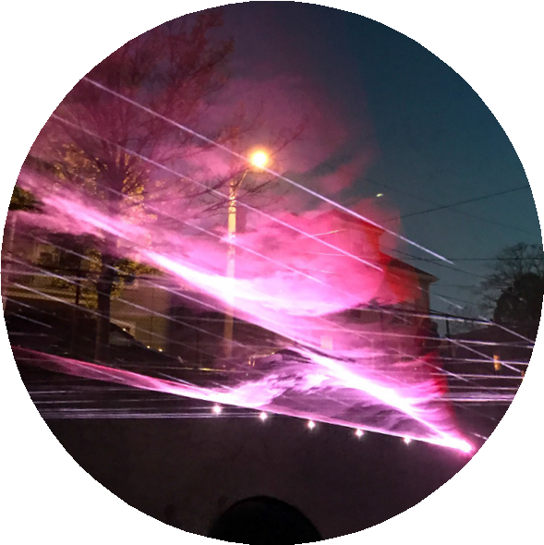Create a sound collage celebrating
the collective voice.
Immersive exhibition that celebrates cultural identity and shared experience is hosted in a free public space.

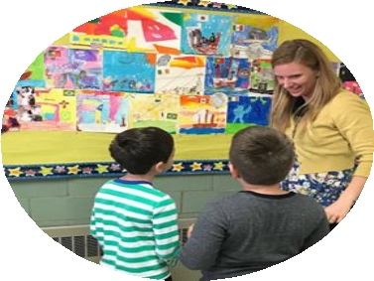

“Is my generation the next voices of change makers? How can we reunite such a fragmented country?”
— Mila McWilliam, age 18, Harbor Voices 2018 Young Artist-in-Residenc

WHAT WE’ VE LEARNED...
- 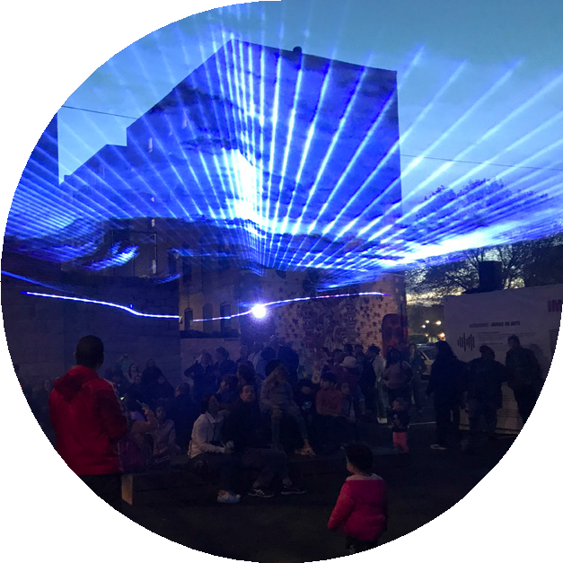Don't wait for the stories to come to you. Get out there and find your participants!

- Buddy Up! Community partners are rich resources for storytelling connections

e

- It's never too late and never too early! People have jobs, lives, and families. Be sensitive of their time. Ask, "When is convenient for you?" and never keep people longer than they are comfortable. Most of our storytelling sessions last between 10-25 minutes.

- Be prepared with specific questions but allow room for stories to unfold.

www.harborvoices.com / action@harborvoices.com / IG: @harborvoices / FB: @harborvoicespublicart

