How to Re-Fashion Your Community

Dr. Karen Weber
Foundation for a Green Future and Boston GreenFest karen@foundationforagreenfuture.org

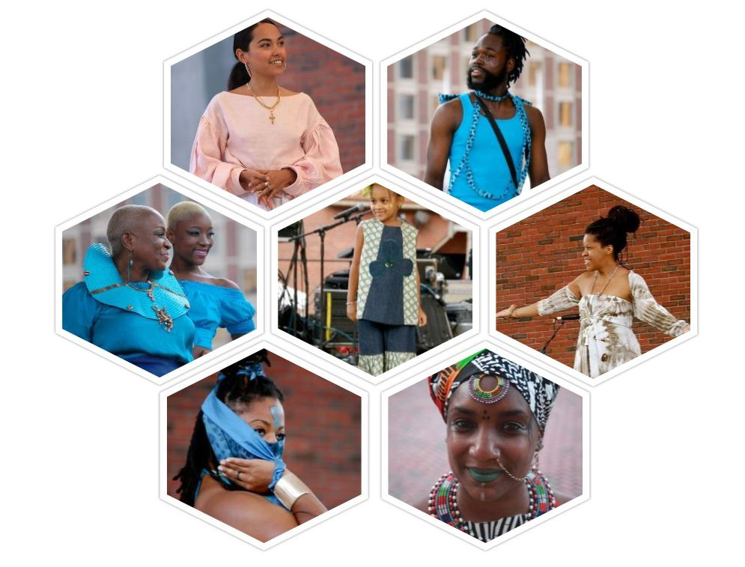

First month: Setting the Stage
  - Make team
    - Find at least one member of the community versed in fashion
    - Find several people interested in fashion or willing to learn
    - Educate each other about EcoFashion and its importance
  - Choose type
    - Repurposed fashion
    - Upcycled fashion
    - Styling
    - EcoArt Design
    - Other
  - Choose theme
    - By color
    - By nature
    - By industry
    - Other
  - Find venue and decide date/time for show

  - Select designers
    - By style and/or type
    - By availability
      - Local
      - Regional
      - Other
  - Seek partners/sponsors
    - High school/trade school teachers
    - College professors in fashion
    - Community members
    - Stores like Goodwill, SAVERS, Boomerangs, Thrift Shops

Second month: Outreach
  - Create an ad/poster
  - Write and send Press Release
    - Establish media list
    - Connect with fashion writers
  - Make flyers and/or palm cards
  - Social media campaign
  - Head to the streets - farmers markets, churches, hair salons, barber shops, mall, supermarkets, etc.
  - Make sure designers have enough models - if not, recruit!

Third month: Finale
  - Find an MC
  - Find make-up artists
  - Find hair stylists
  - Find a DJ or someone to set up the music/audio
  - Dress Rehearsal
  - Showtime
    - Make sure designers and models are on site 3 hours ahead of showtime
    - Make sure MC has script in hand
    - Have fun!

