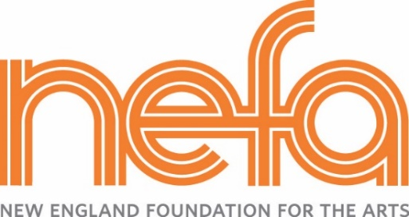
National Dance Project Touring Award – Tour/SHARE Planning Form
(For committed organizations to use up to $35,000 in subsidy)

Date Submitted (NEFA office use only):

Please type or print:

Artist/Company Name:
Name of NDP-supported project to be toured:
Tour Coordinator: |  |  | Tour Coordinator Phone: |  |  |  | Fax:
Tour Coordinator Email:

Instructions:
- As you type, the cells will expand, so please refrain from reformatting the table.
- Add additional rows by right-clicking on the last row and selecting ‘insert rows.’ In order to select the row and not the cells themselves, it is best to click just to the left of the table near the row that you want.
- Email this completed form as a word document to NDP Grants Manager, Dance, Cheri Opperman at copperman@nefa.org
- Save this document for future revisions!

Instructions for fields below:
- All fields are required.
- Fee Subsidy in $: The total fee subsidy should not exceed $35,000.
- Describe Engagement: Examples include concerts, lecture-demonstrations, workshops, panels, Q&As, etc.

Presenter organization | Presenter contact (name/title/mailing  address/phone) | Presenter  Email | Dates of Engagement | Artist fees  (in $) | Fee  subsidy  (in $) | Fee  subsidy  (as % of Artist fee) | Describe engagement  (see examples listed above)
 |  |  | TOTAL

Additional Notes (optional)

