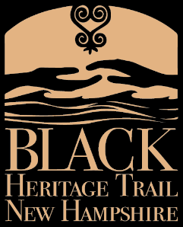
BLACK HERITAGE TRAIL OF NEW HAMPSHIRE
222 Court St. Portsmouth, NH 03801
www.blackheritagetrailnh.org phone: 603-570-8496

Initial Plan for Statewide Expansion of Trail

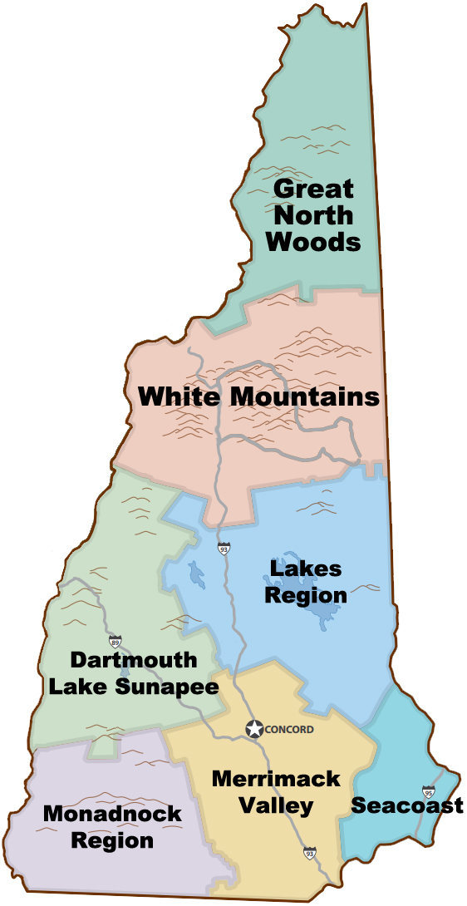
Phase 1: Gather Information & Build Relationships
- Divide the state into the regions
- Identify towns with documented history and known sites
- Identify regional educational institutions for collaboration, partnership & research
7.
  - Identify partners from historical societies, schools, churches and/or community organization.

Phase 2: Raise Awareness
- Host an event/community dialogue in participating towns
- Create web presence (information) for participating towns
6.
- Begin the dialogue around creating K-12 curriculum for towns with multiple sites or regions with single sites
- Share ongoing research

Phase 3: Make History Visible
- Develop tour & train tour guides
5
- Develop audio self-guided tour/Geotourist
- Develop K-12 curriculum
4.
- Fundraise for and install Distinctive BHTNH trail markers at locations

Phase 4: Expand the Work
1.
- Continue expanding outreach through community dialogues
2.
3.
- Develop/share searchable database and continue ongoing research
- Grow Trail and continue statewide research and outreach
- Partner with rBlack history state trails in New England

Region | Partners | Towns/Black History/Individuals/Sites
- SEACOAST  Headquarters - Portsmouth | University of New Hampshire  Exeter Historical Society  Greenland Historical Society  Dover Historical Society  North Church  UCC  Discover Portsmouth | Portsmouth – Well-defined trail serves as model  Dover – Nellie Brown Mitchell, Corydon Chesley  Exeter – The Paul Family/multiple sites  Epping – Cato Fisk  Lee – Cartland House/ National UGRR site  Greenland – Ona Marie Judge Stains  Hampton – Multiple sites/ Knowlton researching  Newmarket – Cheswell Family/ State Marker* Richard Alperin researcher  Durham, Kensington – early stages of research
- MERRIMACK VALLEY | Southern NH University  Rivier College  Milford Historical Society  Milford High School | Milford – Well-developed trail/ Harriet Wilson Statue  Canterbury – Sampson More Battis  Concord – David Watters researching  Henniker– Nancy Prince  Londonderry – Flora Stewart / Wilkinson Rojo researcher  Pittsfield– Frederick Douglas in NH  Amherst, Dunbarton, Hollis, Hopkinton, Manchester- early stages of research
- MONODNOCK | Keene State College  Mason Historical Society  Amos Fortune Forum | Keene– Albert Johnson (story of film “Lost Boundaries”)  Hancock– Multiple sites/ Due Family/Eric Aldrich researcher/ Developed Tour  Jaffrey – Amos Fortune/ State Marker* and historic house  Mason – Boad/ statue  Mount Vernon – Caesar Parker/ Reginald Pitts researcher  Fitzwilliam – early stages of research
- DARTMOUTH-LAKE SUNAPEE | Dartmouth College  Canaan Historical Society  Andover Historical Society  Plainfield Historical Society  Warner Historical Society | Andover – Richard Potter  Canaan – Noyes Academy, Crummel, Garnet, & Paul, (State Marker *)  Newport – Vance Coit and early African American town established by Revolutionary War vets  Plainfield – Derrick Oxford  Warner – Multiple sites/ Developing Tour  Hanover –  Croydon, Goshen, Lempster - early stages of research
- LAKES REGION | Plymouth State University | Plymouth
- WHITE MOUNTAINS | White Mountain CC (Conway) | Gorham and Conway – early stages of research
- GREAT NORTH WOODS | White Mountain CC (Berlin) | Unknown

