Abenaki Heritage Weekend: A case study in decolonizing the relationship between the Native American and Non-Native Communities

Vera Longtoe Sheehan, Director, Vermont Abenaki Artists Association and Abenaki Arts & Education Center

Eloise Beil, Director of Collections and Exhibits, Lake Champlain Maritime Museum

The Abenaki Heritage Weekend is an annual event that takes place on the third weekend of June at Lake Champlain Maritime Museum and is presented through a partnership between Lake Champlain Maritime Museum and Vermont Abenaki Artists Association. Both partners acknowledge that diversity, inclusion, and equity work is challenging as well as rewarding, and requires mutual respect and understanding from both partners.

 | Native American Community | Institution
Planning/Organizing | Before working with museums or institutions start to organize your community. Figure out who your artists, guest speakers, and performers are and create a place/method for the public to find you. | Start by inviting the local Native American stakeholders into the planning process from the beginning.
Understanding | Museums are accustomed to working with professionals; they will expect your community to be professional (make and keep commitments to dates, times, and actions). | Working with a Native American community will be different than working with non-Native partners, offering new perspectives and valuable opportunities for innovation.
Courageous Conversations | There will be times when your institutional partner will not understand something important. Recognize this as an opportunity, and take time to explain. | Be an active listener and allow the Native American community to explain and act on things you may not comprehend or see as a problem.
Acceptance | Accept the help that institutions can offer with contacts, reaching new audiences, and marketing. | Accept that Native American people are experts in their culture and know how to best interpret it for the public.
Equity | Native community organizers can write letters of support to help non-Native partner institutions get funding for mutually beneficial programs. | To have a fair and equitable partnership, your organization needs to privilege the voice of historically marginalized communities and find funding sources to support the production of programs.
Land Acknowledgment | Support land acknowledgements. | Acknowledge that the event is taking place on the land of the local Native American people. Visit Abenaki Arts and Education Center for more details.

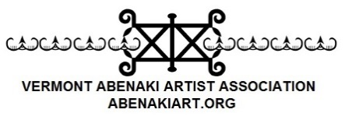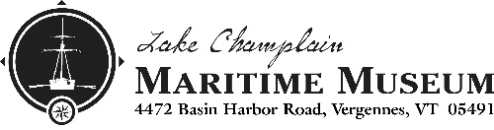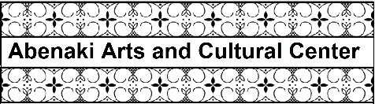

Please visit our websites to learn more about the event:
Lake Champlain Maritime Museum - lcmm.org
Vermont Abenaki Artists Association – abenakiart.org

For Land Acknowledgement and Abenaki curriculum materials please visit:
Abenaki Arts and Education Center – abenaki-edu.org

