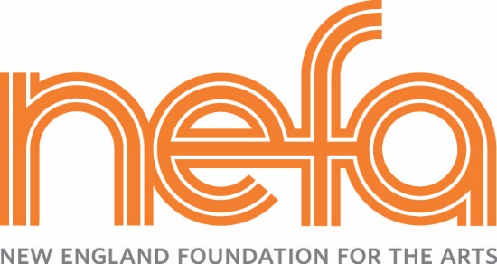
National Dance Project Touring Award – Tour Planning Form
(For committed presenters to use up to $35,000 in subsidy)

Date Submitted (NEFA office use only): __________________________

Please type or print:
Artist/Company Name:
Name of NDP-supported project to be toured:
Tour Coordinator: |  |  |  | Tour Coordinator phone: |  |  | Fax:
Tour Coordinator Email:

Instructions:
- Download this NDP Tour Plan Word file from NEFA’s website: http://nefa.org/grants_programs/grants/national_dance_project_production_grant
- As you type, the cells will expand, so please refrain from reformatting the table.
- Add additional rows by right-clicking on the last row and selecting ‘insert rows.’ In order to select the row and not the cells themselves, it is best to click just to the left of the table near the row that you want.
- Email this completed form to NDP Grants Coordinator Cheri Opperman (copperman@nefa.org).
- Save this document for future revisions!

Instructions for fields below:
- All fields are required.
- Fee Subsidy in $: The total fee subsidy should not exceed $35,000.
- Describe Engagement: Examples include concerts, lecture-demonstrations, workshops, panels, Q&A’s, etc.

Presenter  organization | Presenter contact (name/title/mailing address /phone) | Presenter email | Dates of engagement | Artist fees  in $ | Fee  subsidy  in $ | Fee  subsidy  as % of Artist fee |  | Describe engagement  (see examples listed above)
 |  |  | TOTAL

REQUESTS FOR ADDITIONAL PRESENTERS ABOVE THE $35,000 ALLOCATION

Should additional subsidy become available, NEFA may make additional funds available to tours that have allocated their entire $35,000 subsidy and have additional presenters committed to present the project. Consideration will be given to presentations that take place in traditionally underserved geographic regions of the U.S. and/or include presenters who have not previously received NDP Presentation Grants. List any additional presenters that you would like to be considered for additional subsidy in the space provided below.

Instructions:
- All fields are required.
- List any additional presenters who will be committed to this project should the requested subsidy become available.
(Note: you will be notified as to whether NDP can offer additional funding to the presenters listed below by April 1, 2015.)
- List presenters in order of preference.
- Describe Engagement: Examples include concerts, lecture-demonstrations, workshops, panels, Q&A, etc.

Presenter organization | Presenter contact (name/title/mailing  address/phone) | Presenter  email | Dates of engagement | Artist fees  in $ | Fee  subsidy  in $ | Fee  subsidy  in % | Describe engagement  (see examples listed above)
 |  |  | TOTAL

Additional Notes (optional)

