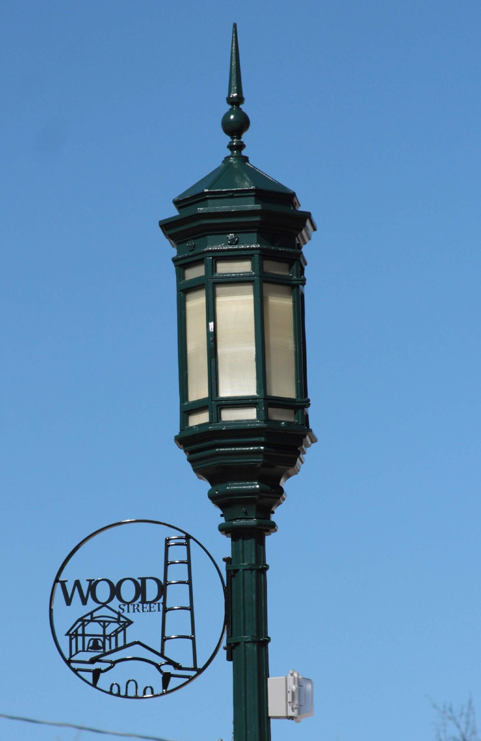The Steel Yard worked with the Town of Bristol over the course of many years to outfit two major thoroughfares with artistic street amenities. These include trash and recycling cans, bike racks, benches, decorative medallions, and planters, to name a few. While bolstering community identity and beautifying streets, the Steel Yard also redistributed funds to artists, local vendor partners, and workforce trainees.

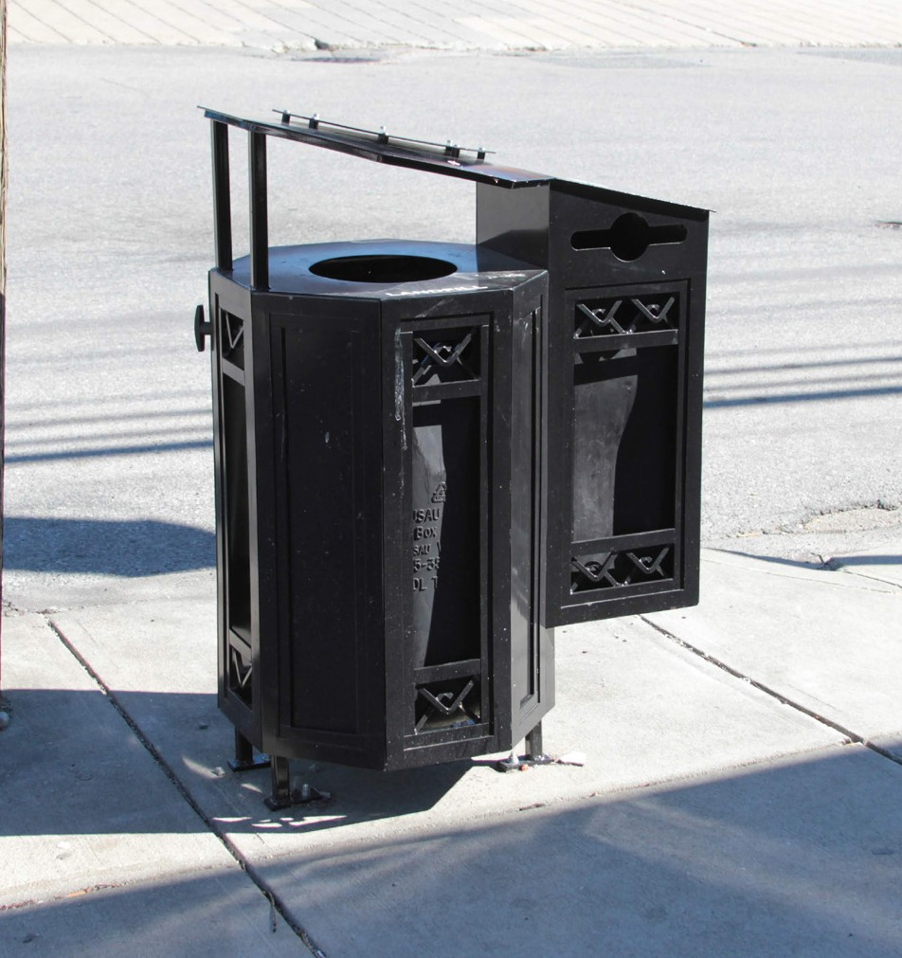We started on and around Hope Street, which is a vibrant street with small businesses, schools, and municipal buildings close to the water and at the end of the the 13 mile East Bay Bike Path. The street hosts the famous Bristol 4th of July Parade, and is a popular tourist attraction.

From 2016 to the present, we have been working together to make unique amenities for the Wood Street neighborhood, which contains some of Bristol’s more industrial sites, higher diversity, a mix of incomes, and more geared towards locals. Here we debuted our side-opening combination trash & recycling cans, as well as decorative medallions for the lamp posts, and bike racks.

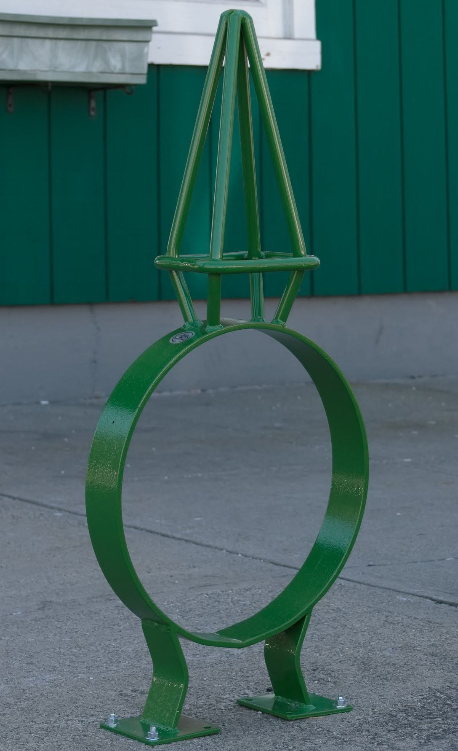HOW DO I DO THIS IN MY COMMUNITY?
- What’s the need?
- Build the Relationship
- Paperwork (estimate, secure funding, contracts)
- Design (hire artists, design, review)
- Fabricate
- Install

TIPS FOR SUCCESS
- Think outside the box! Be creative about what can be art!
- COLLABORATE on grant opportunities
- Leverage funding of other projects
- Start small (Pilot Program) to build trust, and grow
- Participate in community events to increase awareness and community buy-in
- Develop portfolio of work to show competence, emphasize importance of paying artists for design rather than doing it for free
- Incorporate community feedback early, then allow artists to be the experts in design and do what they do best.
- Imitation is the greatest form of flattery. Be an active traveller, and look for inspiration everywhere!
- 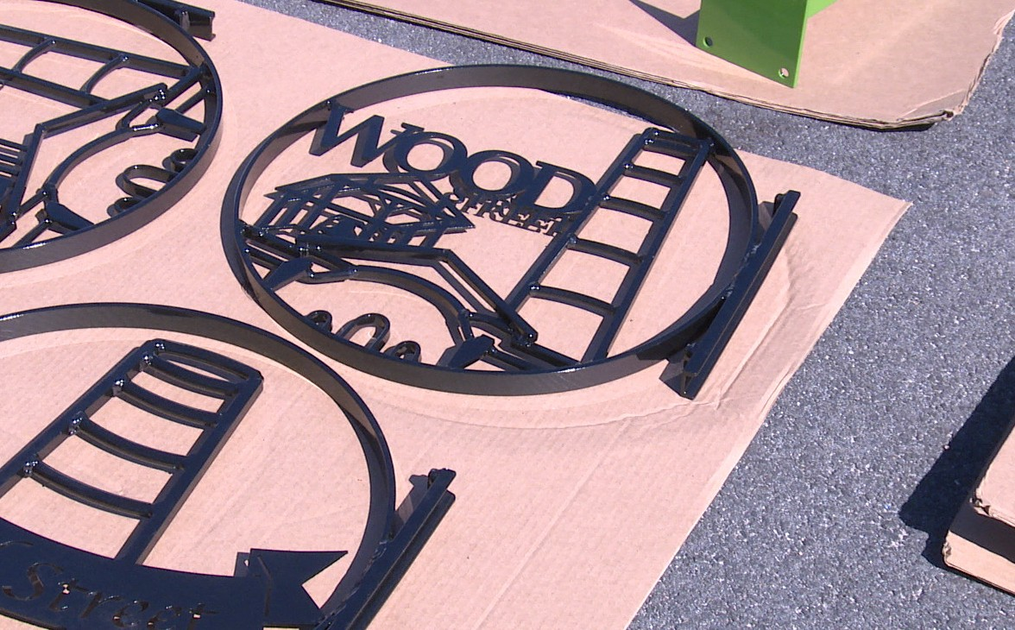Maintain & build good relationships with Town employees to help with logistics
- Opt for larger jobs to increase the appeal to artists
- Be helpful and responsive to the needs of each other; stay engaged
- Look into budgets for amenities.
- Be creative about what and where art can be!
- Trust the artists
- Stay engaged in the process. It’s a big commitment

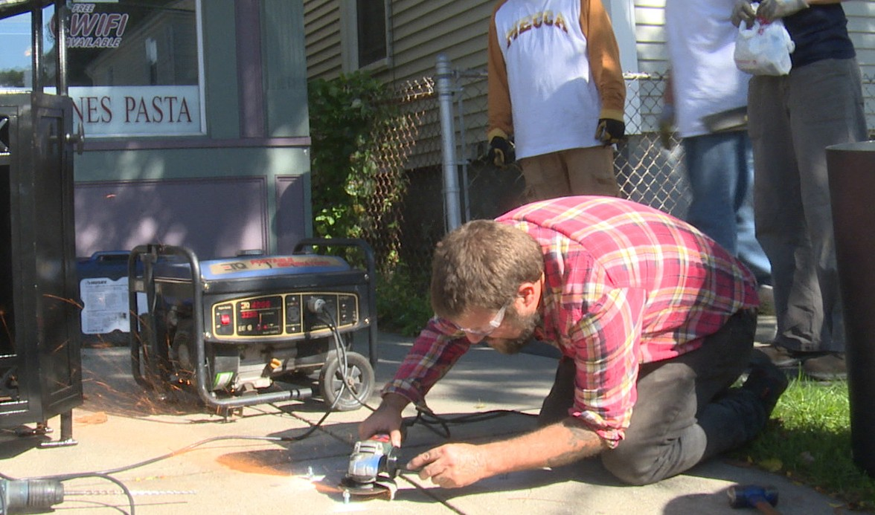Diane M. Williamson
AICP, CFM | Director of Community Development Town of Bristol, Rhode Island
9 Court Street, Bristol, RI 02809
P: 401-253-7000 (ext. 126) | F:401-396-5466

